First Written Assignment (Weight 4%)
Decision Tree Learning
Part a) Consider the following dataset consisting of three features used for predicting class of an object.
F1 | F2 | F3 | Class
Y | L | H | N
Y | H | B | Y
M | L | M | Y
M | H | B | Y
O | L | H | N
O | H | M | Y
Y | L | B | Y

Using decision tree learning algorithm discussed in class to find a decision tree using this data that might be used to predict the class of any new object.
Part b)
Next use the following dataset to a single node learn a decision tree for predicting the price of an object based on two features. Assume that we always partition at the middle while fitting a decision tree
X₁ | X₂ | Price (Y)
1500 | 3 | 350,000
1800 | 3 | 400,000
2400 | 4 | 500,000
3000 | 4 | 550,000
3500 | 5 | 600,000

Part c)
Read about ID3 and CART decision tree learning algorithms and highlight the differences between the two algorithms

KNN Classification and Regression
Part a)
Using the training dataset with a single numeric feature X  - using uniform weights for each nearest neighbor, predict the value of Y at X =4 using KNN with K = 1, 2 and 3 respectively  - Repeat part 1 using weights that are inversely proportionate to the distance of the neighbor from the point | X .Y..  1 2.0  3 2.5  5 3.5  6 4.0

Part b) Describe how would you find a suitable value of k using elbow method?

Part c)
Using the training dataset predict the class of object with two features values (4, 3) using KNN-classifier using K =1, K= 2 and K =3 | X₁ X₂ Y  1 1 0  2 2 0  3 3 1  6 5 1

Part d) Describe a way to assign weight to each nearest neighbor for classifying a new object using KNN

Part e) Repeat part c using weighted KNN classification using your weight assignment of part d

Linear Models
Part a)
For the logistic regression model, use one iteration of gradient descent to update the model parameters using the given dataset  Assume that  - the initial parameters are  [0.1, -0.1, 0.1] with the first parameter representing the bias weight  - Cross Entropy Loss with L₂ regularization is used for training/fitting the model | Dataset  X₀ X₁ X₂ Y  1 1 2 1  1 2 1 0  1 3 4 1

Part b)
Give example of a 2D dataset consisting of 6 training examples that is NOT linearly separable.
Part c)
- Give example of a 2D dataset consisting of 6 training examples that are linearly separable.
- Give weight vector W and bias b of a hyper-plan that separates the positive class from the negative class.
- Write equation of your hyper-plan using W, b and input variables.
Part d)
Read about margin of a classifier and compute the margin (both geometric and numeric) of the following classifier on the given dataset

Part e)
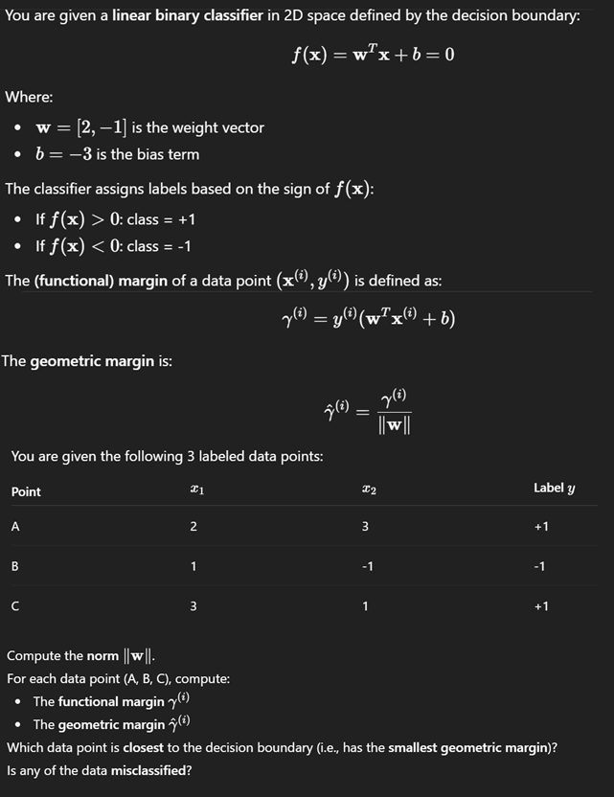
Robotic Fundamentals:
What do we mean by degrees of freedom (DoF)?
What is DoF of a rigid body in 3D space?
How many degrees of freedom does a rigid body have in 3D space if it is only allowed to rotate about a fixed point?

